# Media Analysis - ‘I am not here to take your job,’ ChatGPT tells Frankly Speaking host _Updated 20 March 2023

## Short Summary

The article discusses the capabilities and potential impacts of ChatGPT, an advanced AI language model developed by OpenAI.

## Summary

The article discusses the evolution and potential applications of AI, particularly focusing on OpenAI's ChatGPT model. The article highlights that despite advancements, ChatGPT is not expected to replace human journalists or anchors like Katie Jensen in the near future. It also mentions the upcoming GPT-4 update which aims to improve the naturalness and sophistication of AI-generated text.  
  
The article emphasizes that AI's impact on society will depend on how it is used, and there are concerns about potential negative impacts such as privacy issues, biases, and job displacement. It closes with a hopeful note that if developed and regulated responsibly, AI could bring significant benefits to humanity in various sectors like healthcare, education, and communication. The article also briefly touches upon the growing competition among tech giants like Microsoft, Google, Amazon, Baidu, and Meta, who are investing in similar AI technology.  
  
In the conversation with Arab News, ChatGPT draws on information available online to describe itself, the publication, and the purpose of the interview. It highlights its role as an AI language model and its potential to improve communication and understanding between different cultures and backgrounds.

## Question 1

In the sample analyzed, the media present ChatGPT as a tool with significant potential benefits and concerns. The metaphor of AI technology as a powerful force is prevalent, often portrayed as either a disruptive agent or a means to improve various aspects of society such as healthcare, education, and communication. In some cases, the metaphors used are more positive, emphasizing the tool-like nature of AI, and depicting it as an assistant or facilitator in tasks that would otherwise be difficult or dangerous for humans. For instance, ChatGPT is described as a means to provide access to information and facilitate language translation. However, there are also metaphors that highlight the potential negative impacts of AI, such as concerns about privacy, bias, and job displacement. These concerns are often framed using cautionary or warning-based metaphors, emphasizing the need for responsible and ethical use and regulation of the technology. The media also use a metaphor of a race between major tech companies to develop and integrate AI technology, with Microsoft s integration of ChatGPT into its products serving as an example. This metaphor highlights the competitive nature of the industry and the potential for rapid advancements in AI technology in the coming years.

## Question 2

The article discusses the role and impact of AI technology, specifically focusing on ChatGPT, in the context of journalism and communication. It highlights how AI can be beneficial in various areas such as language translation, providing access to information, and assisting with tasks that are difficult or dangerous for humans. However, it also raises concerns about potential negative impacts of AI, including issues related to privacy, bias, and job displacement. In terms of perspectives being covered, the article provides insights from ChatGPT itself, describing its capabilities and potential uses. It also discusses how developers, policymakers, and users need to be aware of these issues and work together to address them in a responsible and ethical manner. The article mentions that AI technology has the potential to bring tremendous benefits to humanity but emphasizes the importance of regulating it responsibly to avoid negative consequences. Aspects that are being ignored or not explicitly addressed in this specific article include 1. Specific examples of how ChatGPT or other AI technologies have been used in journalism, such as generating news articles, analyzing data for investigative reporting, or automating mundane tasks to free up journalists for more creative and critical thinking work. 2. The potential ethical dilemmas that may arise when using AI in journalism, such as balancing the need for speed and accuracy with maintaining high journalistic standards, ensuring transparency about the use of AI in reporting, and addressing issues related to algorithmic bias. 3. The impact of ChatGPT and other AI technologies on the job market for human journalists, including potential job losses due to automation and the ways in which AI could be used to augment rather than replace human journalists. 4. The role of AI in shaping public discourse and the potential risks posed by AI-generated disinformation or propaganda. 5. The long-term implications of AI technology on society, such as its impact on privacy, democratic institutions, and cultural values. 6. The state of AI research and development in different regions around the world, including emerging markets and less developed countries, and how these differences might influence the deployment and use of AI technologies in journalism. These topics are relevant to understanding the role of AI in journalism and communication and should be considered when evaluating the impact and potential of AI on this field.

## Question 3

Not mentioned

## Question 4

The article highlights the potential of AI, represented by ChatGPT, in enhancing communication and understanding across cultures while also addressing concerns about privacy, bias, and job displacement. It emphasizes that the impact of AI depends on how it s used and regulated, calling for a collaborative approach between developers, policymakers, and users to ensure its benefits are maximized for humanity s wellbeing.

## Sentiment

The sentiment is 5

## Entities

Google, Edge, OpenAI, Arab News, Bard, Microsoft, Meta, AI, Baidu, Bing, Jensen, Amazon, ChatGPT, Frankly Speaking, Katie Jensen, Sam Altman

## Highlights

#c885da#f9cd59#7cc867#fb5b89#69aff0

## Wordcloud for #c885da Highlights

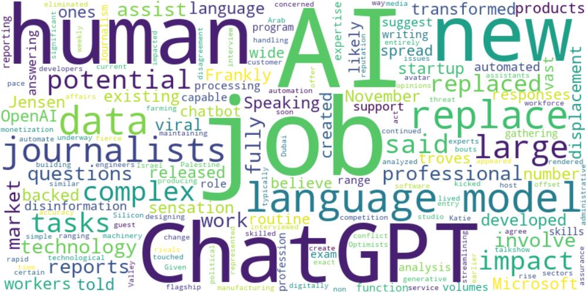

Top 10 words:

- AI: 18

- jobs: 10

- language: 10

- ChatGPT: 9

- human: 9

- job: 7

- data: 7

- replace: 7

- journalists: 7

- large: 6

## Wordcloud for #f9cd59 Highlights

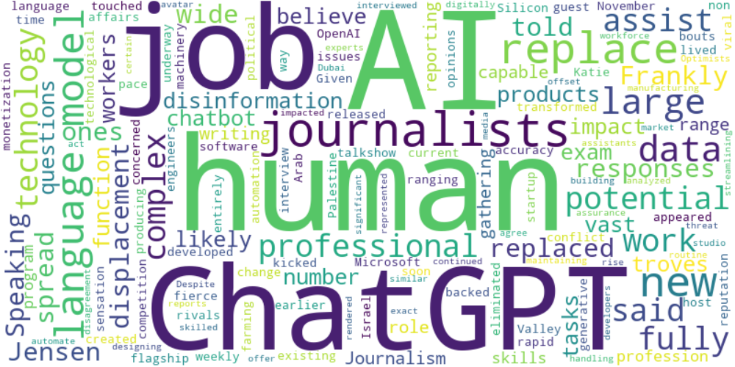

Top 10 words:

- AI: 10

- human: 9

- ChatGPT: 7

- journalists: 7

- language: 6

- replace: 6

- jobs: 4

- large: 4

- data: 4

- like: 3

## Wordcloud for #7cc867 Highlights

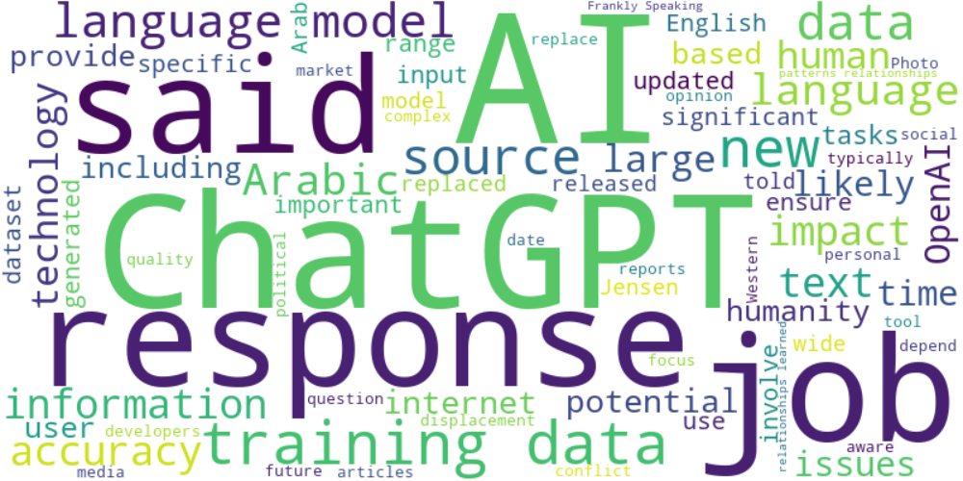

Top 10 words:

- AI: 27

- data: 24

- ChatGPT: 20

- language: 18

- training: 16

- responses: 14

- said: 14

- jobs: 9

- sources: 9

- new: 8

## Wordcloud for #fb5b89 Highlights

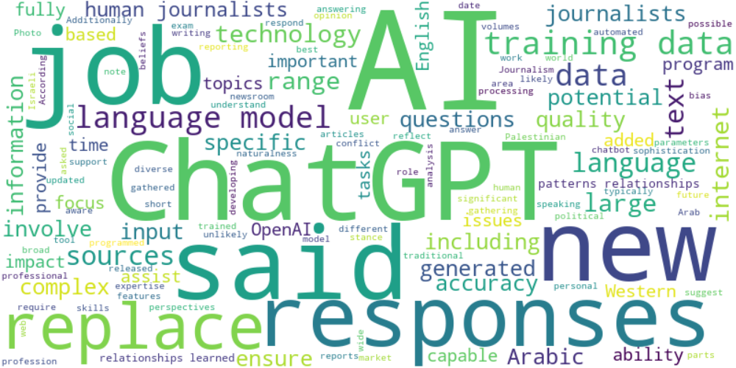

Top 10 words:

- AI: 22

- data: 17

- language: 14

- ChatGPT: 13

- said: 11

- responses: 10

- training: 10

- replace: 9

- journalists: 8

- jobs: 7

## Wordcloud for #69aff0 Highlights

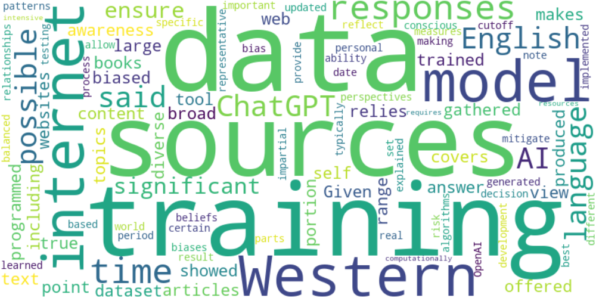

Top 10 words:

- data: 5

- sources: 4

- training: 4

- Western: 3

- internet: 3

- model: 3

- responses: 3

- time: 3

- English: 2

- possible: 2